1. **8 BIT ADDITION:**

LDA 4500

MOV B, A

LDA 4501

ADD B

STA 4502

RST 1

Hlt

**OUTPUT:**

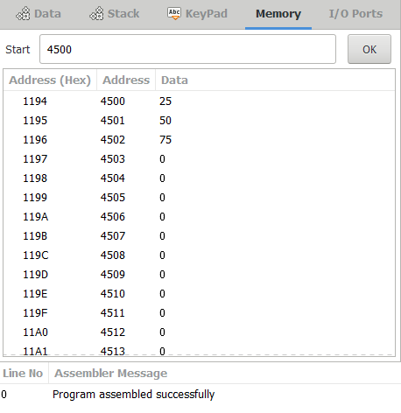

1. **8 BIT SUBTRACTION:**

LDA 8000

MOV B, A

LDA 8001

SUB B

STA 8002

RST 1

Hlt

**OUTPUT:**

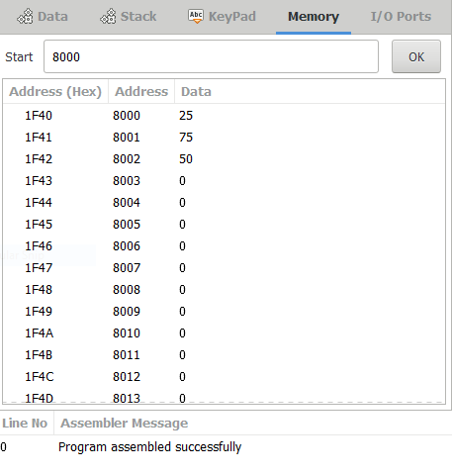

1. **BIT MULTIPLICATION:**

LDA 4200

MOV E,A

LDA 4202

MOV B,A

LXI H,0000H

MVI D,00H

NEXT: DAD D

DCR B

JNZ NEXT

SHLD 4205h

hlt

**OUTPUT:**

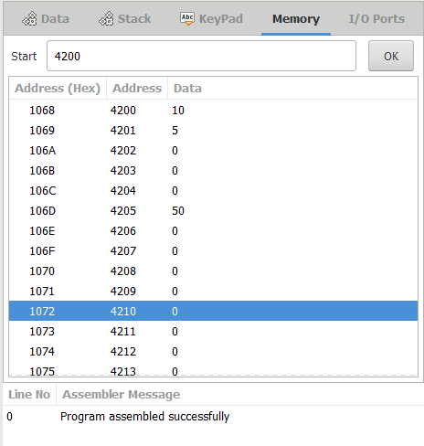

1. **8 BIT DIVISION:**

LDA 4201

MOV B,A

LDA 4200

MVI C,00H

AGAIN: CMP B

JC STORE

SUB B

INR C

JMP AGAIN

STORE: STA 4202

MOV A,C

STA 4203

Hlt

**OUTPUT:**

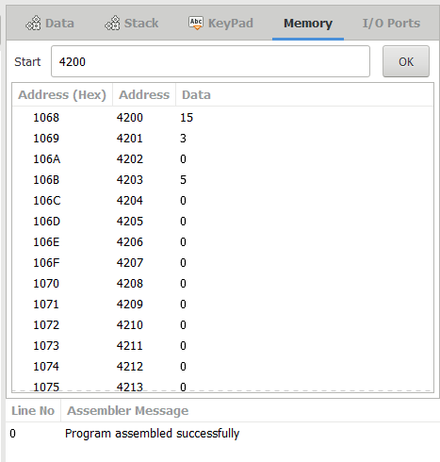

**5.16 BIT ADDITION:**

LDA 3050

MOV B,A

LDA 3051

ADD B

STA 3052

LDA 3053

MOV B,A

LDA 3054

ADC B

STA 3055

HLT

**OUTPUT:**

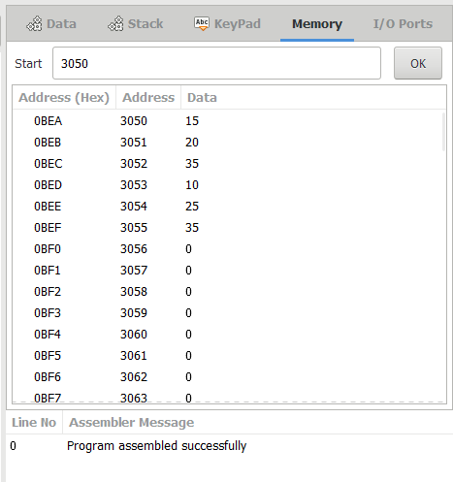

**6. 16 BIT SUBTRACTION:**

LDA 3050

MOV B,A

LDA 3051

SUB B

STA 3052

LDA 3053

MOV B,A

LDA 3054

SBB B

STA 3055

HLT

